**Reset the Jenkins Password** 05/07/23

Step 1: to reset the password we need to goto the **config.xml** file which is located in the **/var/lib/Jenkins/** directory and change **userSecurity** to **false** to connect to the Jenkins webpage without password.

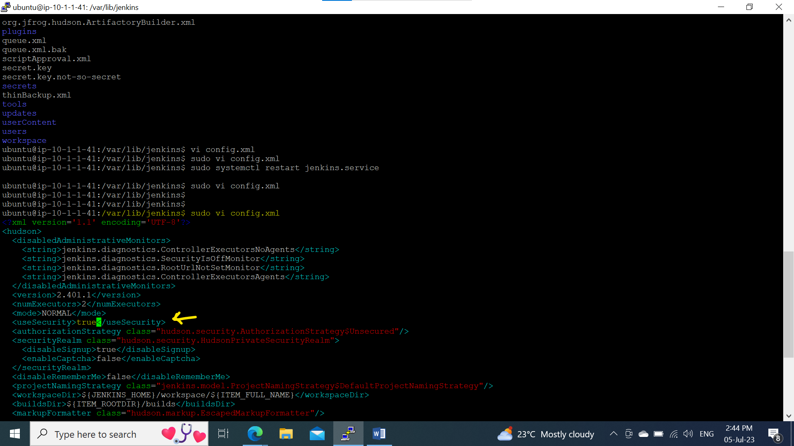

Step 2: Restart the **Jenkins.service**.

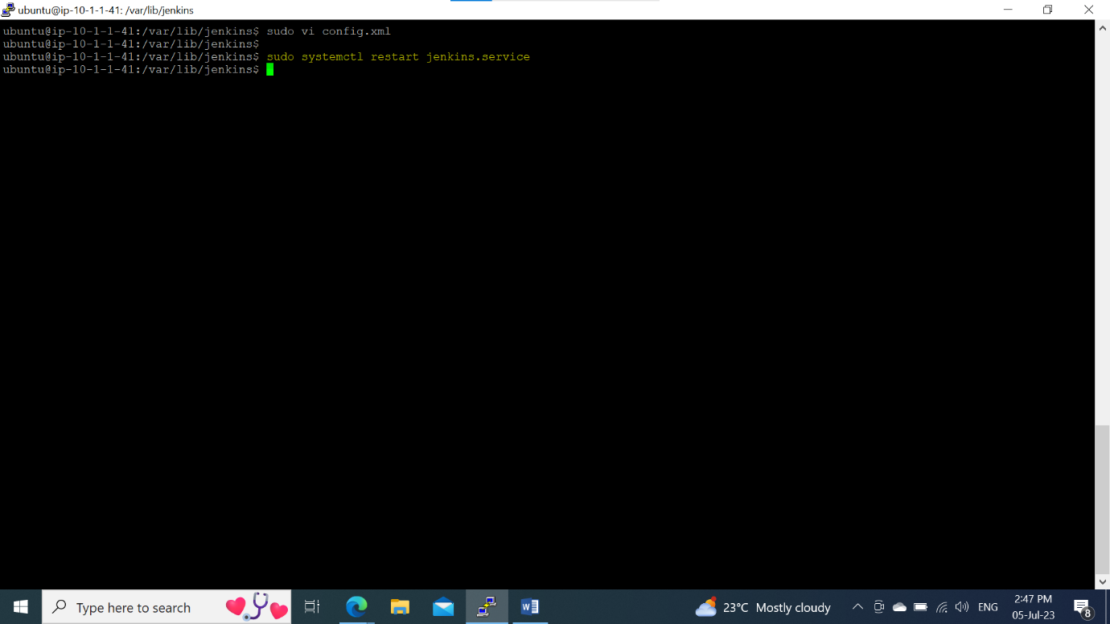

Step 3: logged into the Jenkins webpage without password

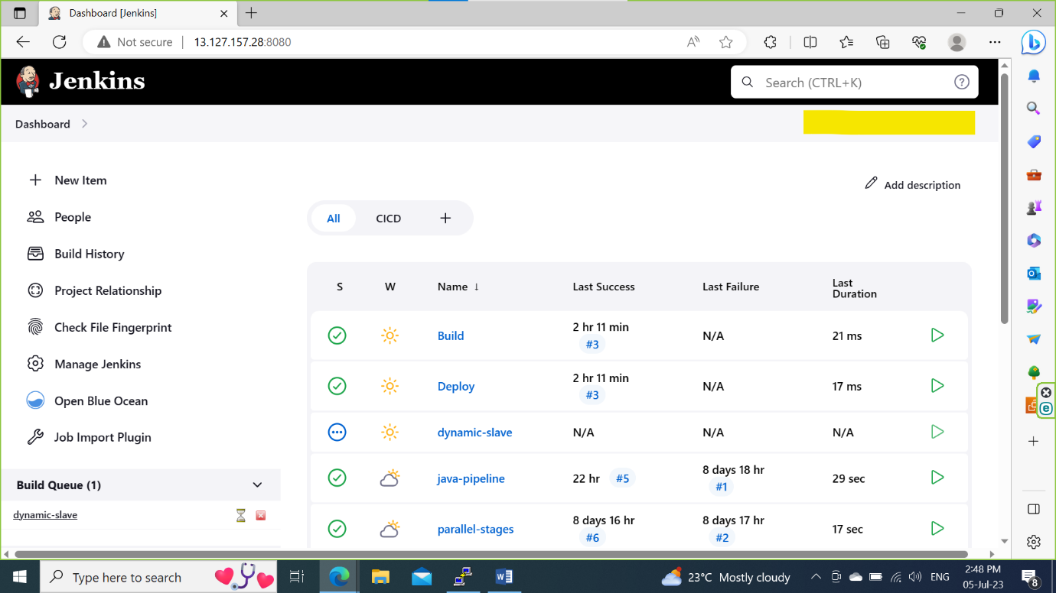

Step 4: goto **manage Jenkins**, click on **security** and dropdown the **Security Realm** and select the **Jenkins** **own base database** and **Save.**

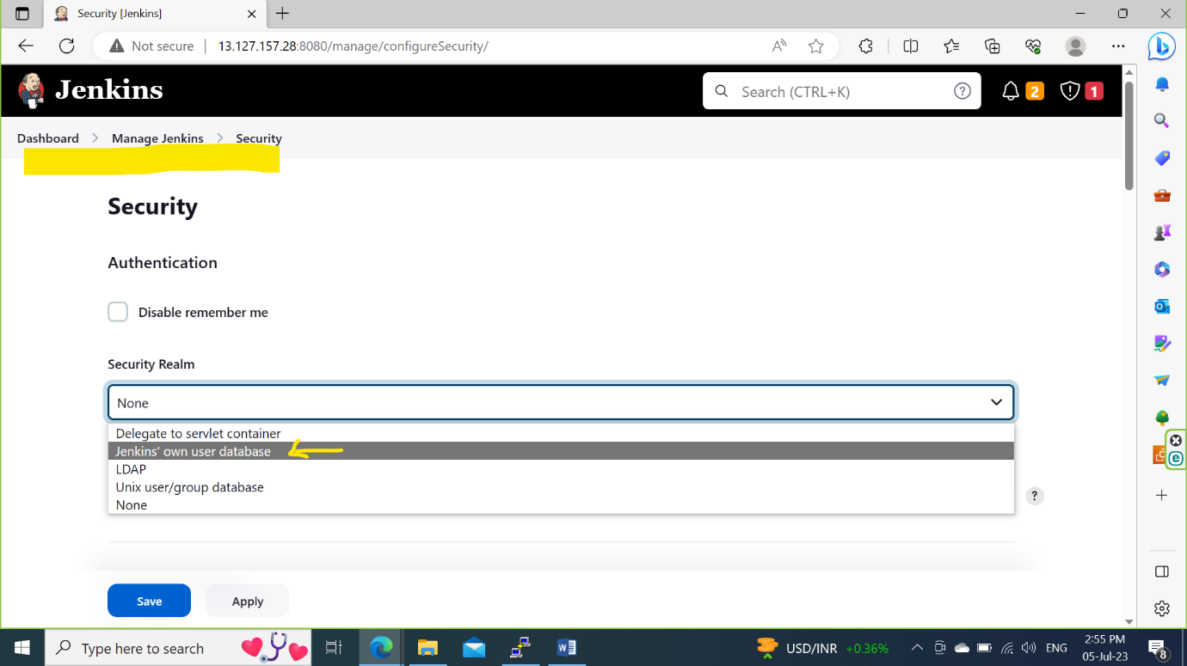

Step 5: goto to **Manage Jenkins** and click on the **Users**.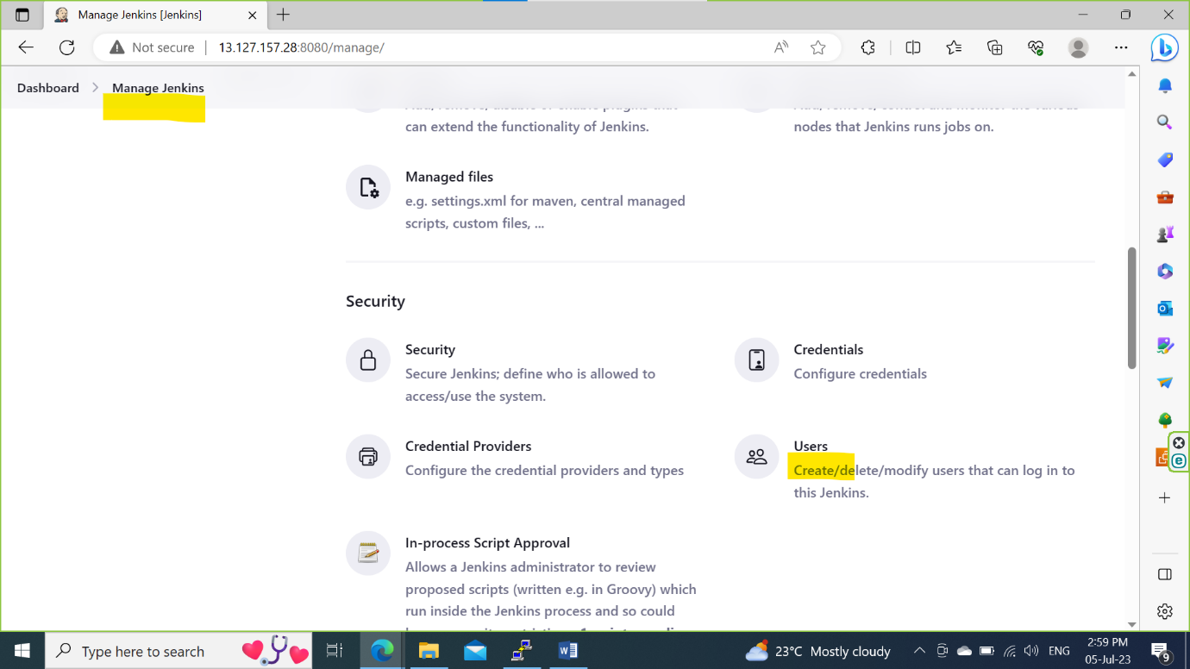

Step 6: Select the User(admin) and click on configure to change the password.

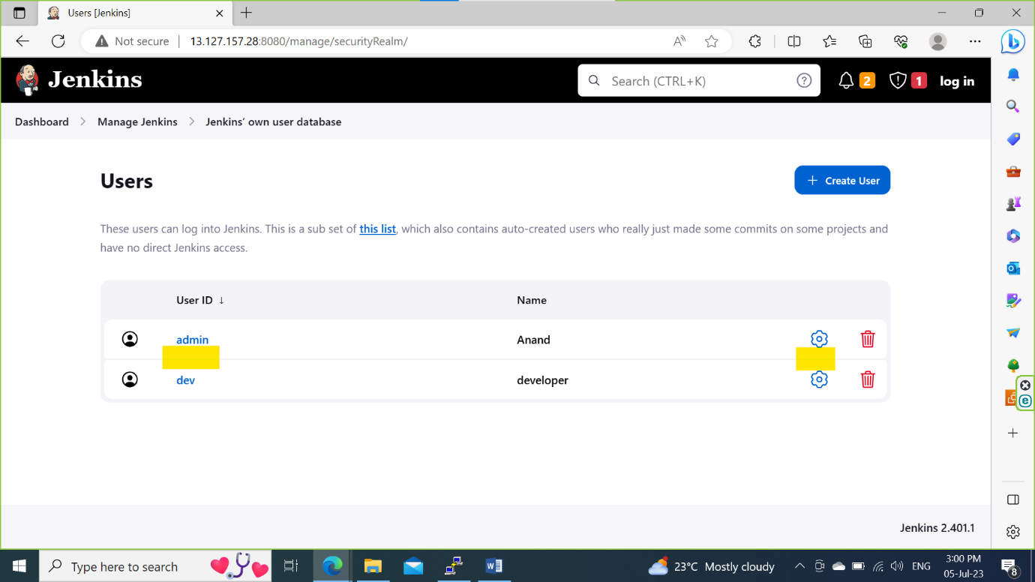

Step 7: Navigate to the **Password** and change the password here and **Save**

